* **Lab Task 5:**

### Display the Airline and the Minimum Ticket Price, Excluding Certain Flights

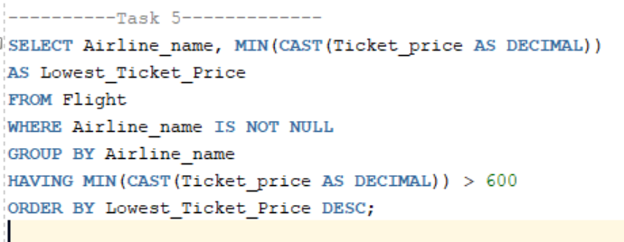

Output:

